Homework Assignment 4

Rahul Avadhoot

October 20, 2017

salary <- read.table("http://faculty.washington.edu/tathornt/Biost509/DataSets/salary.txt", header = TRUE)

## Question 1

boxplot(salary~rank,data = salary,xlab="Rank", ylab="Salary", main="Boxplots of Salary for each Rank",col=topo.colors(3))  
legend("topright",title="Rank",c("Assist","Assoc","Full"),fill=topo.colors(3))

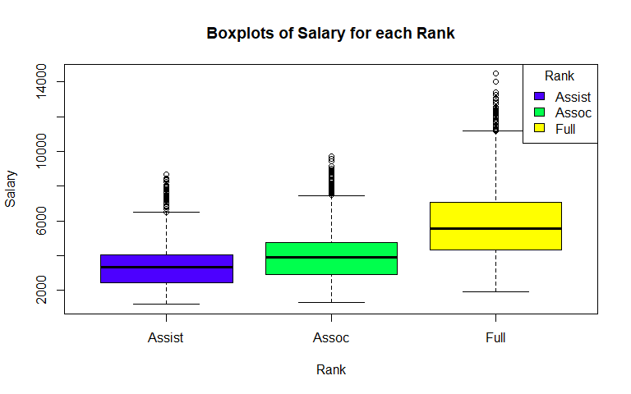

## Question 2

boxplot(salary~interaction(gender,rank),  
 data = salary,  
 xlab = "Gender . Rank",  
 ylab = "Salary",  
 main = "Boxplots of Salary for each combination of Gender, Rank",  
 col=(c("pink","lightblue")))  
legend("topleft",title="Gender",c("Female","Male"),fill=c("pink","lightblue"))

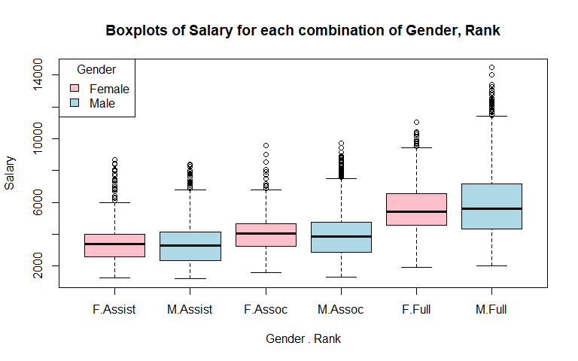

## Question 3

subset = salary[salary$id %in% c(6,7,10,12),]  
plot(salary~year,  
 data = subset,  
 xlab = "Year",  
 ylab = "Salary",  
 main = "Scatterplot of Salary vs Year for selected IDs",  
 col = as.integer(rank),  
 pch = as.integer(rank))  
legend("topleft",title="Rank",c("Assist","Assoc","Full"),pch=1:3,col=1:3)

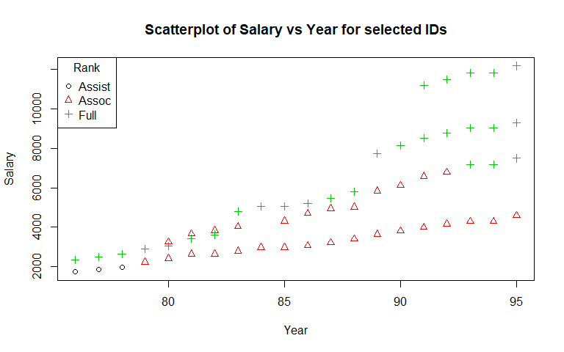

## Question 4

plot(subset$year,subset$salary,  
 xlab = "Year",  
 ylab = "Salary",  
 main = "Scatterplot of Salary vs Year for selected IDs",  
 col = subset$id)  
lines(subset[subset$id==6,]$year,subset[subset$id==6,]$salary,  
 col=subset[subset$id==6,]$id,  
 lwd=2)  
lines(subset[subset$id==7,]$year,subset[subset$id==7,]$salary,  
 col=subset[subset$id==7,]$id,  
 lwd=2)  
lines(subset[subset$id==10,]$year,subset[subset$id==10,]$salary,  
 col=subset[subset$id==10,]$id,  
 lwd=2)  
lines(subset[subset$id==12,]$year,subset[subset$id==12,]$salary,  
 col=subset[subset$id==12,]$id,  
 lwd=2)  
legend("topleft",title="ID",c("6","7","10","12"),  
 col=c("6","7","10","12"),  
 lwd=2)

